# Benthic monitoring summary: American Samoa 2018

## About this summary

The purpose of this document is to provide a brief summary of the most recent survey efforts performed in American Samoa in 2018 by the Ecosystem Sciences Division (ESD) of the NOAA Pacific Islands Fisheries Science Center as part of the Pacific Reef Assessment and Monitoring Program (Pacific RAMP). A more detailed assessment of the coral populations and reef community structure from American Samoa) will be summarized in future publications.

## Sampling effort

* Ecological monitoring in American Samoa was performed from June 19 - July 18, 2018.
* Surveys were conducted at 95 sites across 5 islands: Swains, Tutuila, Ofu & Olosega, Tau, and Rose.
* Coral demography, partial mortality, and condition were surveyed using belt transects; benthic community structure will be assessed from photoquadrat digital images.

Table 1. Forereef area (hectare) and number of sites surveyed (nS, nM and nD = the number of sites surveyed within shallow, mid and deep strata, respectively)

in American Samoa.

|  |  |  |  |  |  |  |
| --- | --- | --- | --- | --- | --- | --- |
| Island | Shallow | nS | Mid | nM | Deep | nD |
| Ofu & Olosega | 121 | 4 | 369 | 7 | 304 | 6 |
| Rose | 18 | 5 | 85 | 6 | 17 | 3 |
| Swains | 211 | 4 | 57 | 3 | 12 | 2 |
| Tau | 134 | 3 | 566 | 8 | 204 | 4 |
| Tutuila | 1184 | 9 | 1802 | 17 | 1492 | 14 |

## Overview of data collected

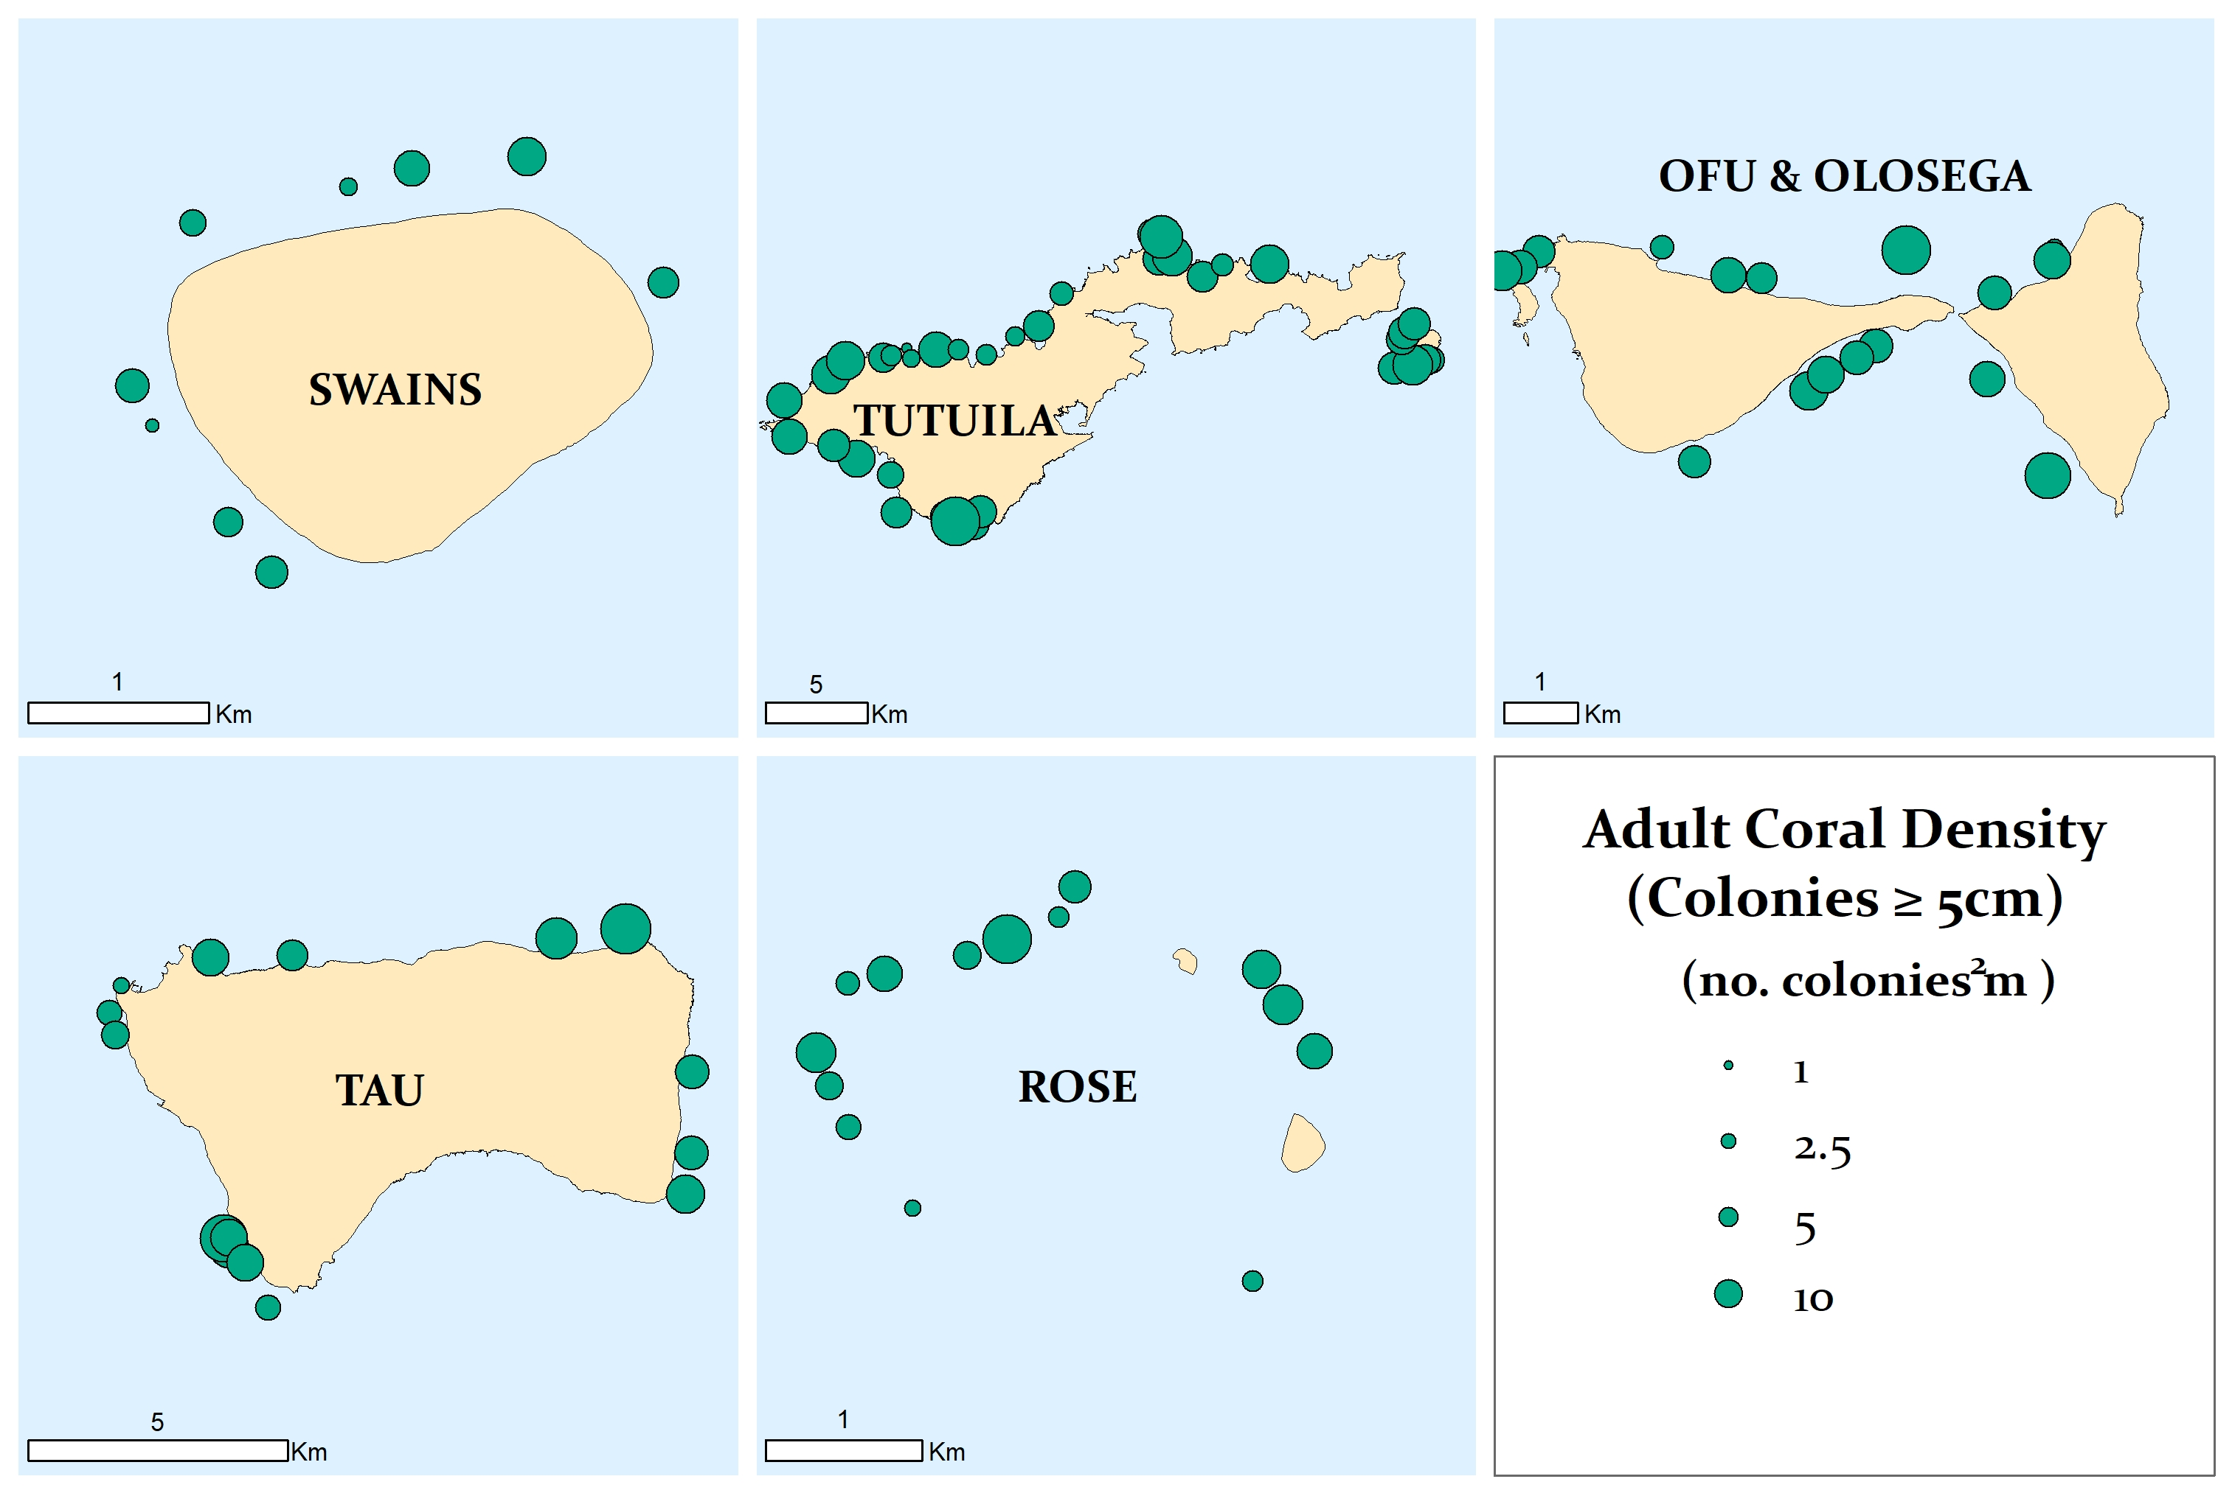

Figure 1. Mean density of adult coral colonies (Scleractinia, ≥ 5 cm) at survey sites.

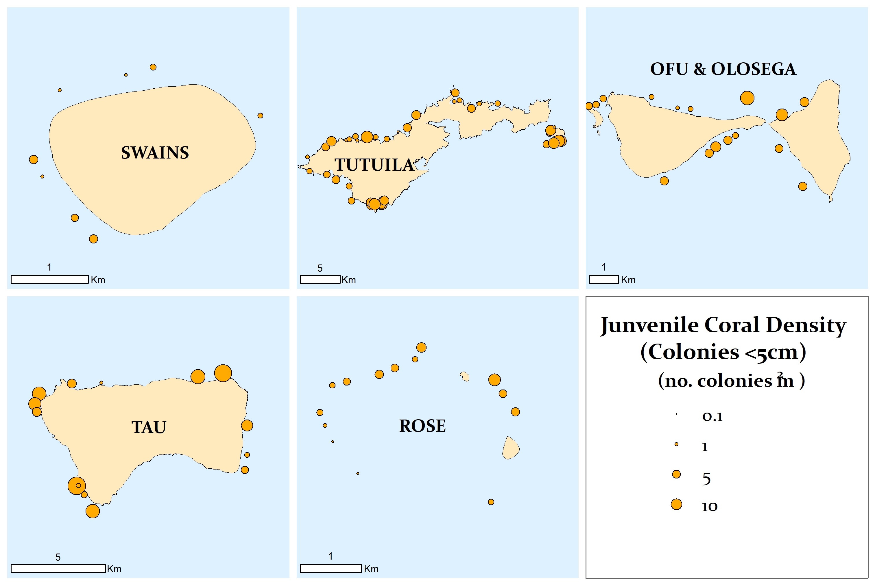

Figure 2. Mean density of all juvenile coral colonies (Scleractinia, < 5 cm) at survey sites.

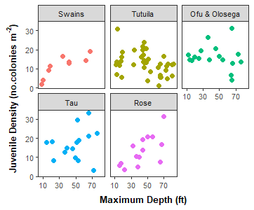

Figure 3. Density of juvenile coral colonies grouped by island across maximum site depth (ft).

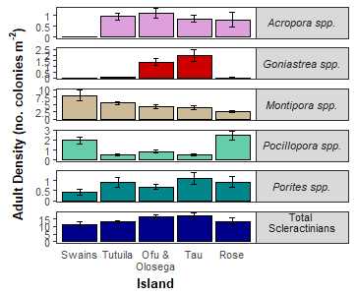

Figure 4. Mean island-wide density of adult colonies (± SE) for total scleractinians and the five most abundant genera: *Acropora*, *Goniastrea*, *Montipora*, *Pocillopora*, and *Porites*. Note: the scale of the y-axis is not consistent across taxa.

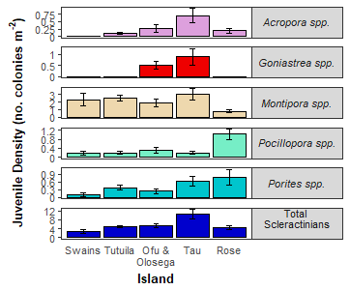

Figure 5. Mean island-wide density of juvenile colonies (± SE) for total scleractinians and the five most abundant genera: *Acropora*, *Goniastrea*, *Montipora*, *Pocillopora*, and *Porites*. Note: the scale of the y-axis is not consistent across taxa.

*Coral condition and threatened species*- The percent of adult coral colonies exhibiting signs of bleaching, disease, or crown-of-thorns sea star (COTS) predation lesions as well as the mean percent of each colony with partial mortality are shown in Table 2. Bleaching included any loss of pigmentation. Acute Disease was defined diseases resulting in tissue mortality. Chronic Disease refers to diseases that do not result in tissue loss. COTS was defined as recent coral mortality attributable to COTS predation. The Endangered Species Act threatened species *Isopora crateriformis* was observed at Ofu & Olosega, Tutuila and Tau. *Acropora retusa* was observed at Rose and *Acropora globiceps* was observed at Tutuila.

Table 2. Percent of adult coral colonies that exhibited bleaching (BLE), acute and chronic disease, crown-of-thorns sea star (COTS) predation lesions and partial mortality (including old and recent).

|  |  |  |  |  |  |
| --- | --- | --- | --- | --- | --- |
| Island | %BLE | %Acute Disease | %Chronic  Disease | %COTS | %Mortality |
| Ofu & Olosega | 0.11 | 0.66 | 0.07 | 0.00 | 11.65 |
| Rose | 0.62 | 0.95 | 0.00 | 0.00 | 8.77 |
| Swains | 5.16 | 0.16 | 0.21 | 0.00 | 15.70 |
| Tau | 0.00 | 0.27 | 0.27 | 0.00 | 13.13 |
| Tutuila | 0.22 | 0.90 | 0.51 | 0.03 | 11.12 |

## 

## Preliminary observations

At Howland and Baker in 2017, divers reported patches of coral mortality on the west side; however, preliminary observations in 2018 suggest no comparable mortality occured. Reefs anecdotally appeared to be in good condition (i.e. no mass bleaching or disease outbreaks). Swains experienced thermal stress and mass bleaching during the bleaching 2015-2016 event, which resulted in considerable *Pocillopora* mortality. In 2018, divers noted an increase in dead *Pocillopora* colonies.

At Tutulia, weather conditions precluded work along the southern forereef and Aunu’u Management Areas, but no bleaching or disease outbreaks were noted along the northern coastline. At Ofu, Olosega and Tau, weather conditions limited survey work along the south and east facing forereef habitat. Overall, divers reported that reefs appeared to be in good condition. At Tau, a large colony of massive *Porites* comparable in size to “Big Momma” was sighted along the east facing forereef. At Rose, similar to previous years, forereef coral communities were dominated by crustose coralline algae (CCA); *Pocillopora* was the most abundant coral genus. Surveys conducted at the old wreck site revealed the persistence of extremely low coral cover, low levels of CCA and high black cyanophyte cover. It appears that the remaining metallic debris continues to leach chemicals resulting in the cyanobacterial proliferation historically observed at this site.

## Survey design & methods

A single stage stratified random sampling design was employed to survey American Samoa. The stratification scheme incorporated all forereef, hard bottom habitats, and sampled across three depth categories: shallow (0-6 m), mid (>6-18 m) and deep (>18-30 m). Allocation of sampling effort was proportional to total strata area. Sites (geographic coordinates) were randomly selected within each stratum.

Coral demography surveys at each site were conducted along one belt transect. Adult coral colonies (≥ 5 cm) were surveyed within 10 m2 and juvenile coral colonies (< 5 cm) were surveyed within 3 m2 on each transect. Colonies were identified to the lowest taxonomic level possible, measured (maximum diameter to the nearest cm), and morphology was noted. In addition, partial mortality and condition of each colony was assessed. Partial colony mortality was quantified as the percent of old and recent dead tissue, and attributed to cause of mortality when known. Conditions affecting each colony (i.e., disease and bleaching) were noted, along with the extent (percent of colony affected) and severity (ranging from moderate to acute). See <https://repository.library.noaa.gov/view/noaa/18267> for details on survey methodology

The present summary focuses only on colony density and initial estimates of bleaching, disease, and COTS predation occurrence. The island-scale estimates presented here are generated from site-level means and are not weighted by reef area within depth strata, statistical analyses are forthcoming.

## About the monitoring program

Pacific RAMP forms a key part of the National Coral Reef Monitoring Program of NOAA’s Coral Reef Conservation Program (CRCP), providing integrated, consistent, and comparable data across US Pacific islands and atolls. CRCP monitoring efforts have these aims:

* Document the status of reef species of ecological and economic importance
* Track and assess the status and trends of US coral reef ecosystems in response to environmental stressors and human activities
* Evaluate the effectiveness of specific management strategies and identify actions for future and adaptive responses

In addition to the coral population and benthic community surveys outlined here, Pacific RAMP efforts include interdisciplinary monitoring of oceanographic conditions, fish population and assemblages, invertebrate diversity and abundance, coral reef habitat assessments and mapping, and studies of the effects of climate change and ocean acidification.

## For more information

Coral Reef Conservation Program:  
<http://coralreef.noaa.gov>  
NMFS Pacific Islands Fisheries Science Center:  
<http://www.pifsc.noaa.gov>  
Related publications:  
<http://www.pifsc.noaa.gov/pubs/credpub.php>  
Additional information:  
<http://www.pifsc.noaa.gov/cred/benthic_monitoring.php>  
Benthic survey data requests:  
[courtney.s.couch@noaa.gov](mailto:courtney.s.couch@noaa.gov)